Project 2 – Wireshark: TCP with your own server, report format CS 438/538, 2022 Fall Hong
Project description is also given in the WS-TCP-yourWebserver.pdf
The TCP lab guide and questions are given in "Wireshark_TCP_v8.1.pdf".
A Few Revised Project Steps
- Follow project description. Run you own servers and use provided files. Substitute their server and files with your server and files.
- Follow the steps in the description of Wireshark Lab: TCP, learn how to investigate TCP with your server version V2. Try on file RandomText.txt or CahabaLily.jpeg. Do 3. TCP Basics, answer the questions of 1 - 5, 7-10 (#5 be GET).
- Investigate TCP with your server V2 and tree.JPEG. Do 4. TCP congestion control in action, answer the questions of 12 and 13.
- Submit your answers to the questions in table format. Sample formats are given below. Allowed graphs are specified in the table. DO NOT submit other photos/screenshots as well as your annotations excepts.
Example Tables (do not copy-paste lengthy text, only the numbers are needed most cases.

2. A first look at the captured trace
 | IP and TCP port# of Client |  | IP and TCP port# of the server
Q1 | 127.0.0.1:51109 | Q2 | 127.0.0.1:6789

3. TCP Basics.
Question 4-6 (WS hints are given in the table)
 | Sequence # in segment type | ACK Sequence # in segment type | What are in header to identify a segment type (SYN or SYN ACK)
Q3 | SYN 3398989717 | ACK 0 | SYN bit set to 1
Q4 | SYNACK 1691899498 | SYNACK 3398989718 | SYNACK: Both SYN and ACK bit set to 1
Q5 | HTTP GET 3398989718 | ACK 1691899499 | SYNACK: ACK bit set to 1

Questions 7 and 8.
Order of segments | length | Receiver window | Any lack of buffer
#1 | 39 bytes | 64768 | No
# 2 | 65300 bytes | 64768 | No
# 3 | 65300 bytes | 64768 | No
# 4 | 65515 bytes | 64768 | No
# 5 | 49944 bytes | 64768 | No
# 6 | 22 bytes | 64768 | No

Questions 9 -10.
 | value | explanations
Q9 | 0 retransmitted segments | Looked for buffer overflows and congestion
Q10 | All data | No retransmission needed

4. TCP congestion control in action
Questions 12 -13. Use server V2 and tree.JPEG.
Q12 Insert the Time Sequence Graph below
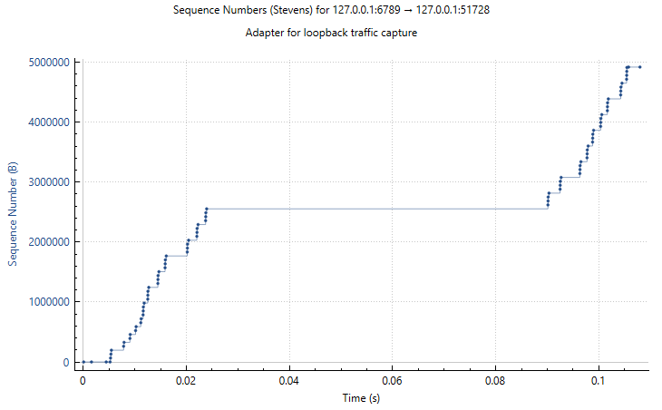
Q13 Explanation
- From the graph, it appears that a fleet of segments is transmitted approximately every 0.03–0.04 seconds.
- The first burst starts at 0s and increases sequence numbers steadily until around 0.025s.
- Then, there is a pause (flat line) until around 0.07s, where the next burst occurs.
- This indicates a recurring interval of approximately 0.03–0.04s.
- The periodicity of the fleets appears to be approximately 30–40 ms.
- The pattern suggests TCP congestion control behavior, receiver window limitations, or delayed ACKs.
- Further investigation could include checking window size changes and RTT estimates using Wireshark’s TCP analysis tools

5. Additional: comparisons of response time and explanation
Describe your methods of grabbing data and calculating response time. There may be different ways. If needed, you could show your method using annotated images. Show the comparison results and write your explanations for the following two tasks:
Retrieve CahabaLily.jpeg for each server version respectively. Capture and calculate response time for each case. Generate one table comparing the response times of the three servers and explain.
Versions | V1 | V2 | V3
Time | 12.305261000 sec | 0.005826000 sec | 0.004486000 sec
- Why is V1 so slow?
- V1 uses send() in a loop, sending one byte at a time.
- Since each send() call incurs a system call and TCP overhead, this results in thousands (or millions) of calls for large data.
- Context switching between user space and kernel space adds significant delay.
- TCP Nagle’s algorithm may further delay small packets.
- Key issue: High system call overhead due to many small sends.
- Why is V2 much faster?
  - V2 uses a single send() call to send all data at once.
  - This significantly reduces system call overhead compared to V1.
  - However, TCP does not guarantee full data transmission in one send() call—it may send only part of the data.
  - Key improvement: Fewer system calls, faster transmission.

3. Why is V3 the fastest?
- V3 uses sendall(), which ensures all data is sent before returning.
- Unlike send(), sendall() handles partial sends internally, retrying automatically until all data is sent.
- This eliminates the need for application-level handling of partial sends.
- While sendall() works over both TCP and UDP, in a TCP context, it ensures that all data is pushed to the socket efficiently.
- Key improvement: Guaranteed full transmission, reduced need for manual handling

Retrieve tree.jpg for server version V2 only. Capture and calculate response time. Generate one table comparing the response times of server V2 for the files of CahabaLily.jpeg and tree.jpg and explain.
Version | Image | Time
V2 | CahabaLily.jpeg | 0.005826000 sec
V2 | tree.jpg | 0.107995000 sec
- Smaller image (CahabaLily.jpeg): The response time is lower because there is less data to transfer.
- Larger image (tree.jpg): The response time is higher due to the larger size, resulting in more data to transfer, which increases the time it takes for the TCP connection to handle the transmission.

Submission Formatting:
- The report file uses your name and lab as the file name.
- In the file, have your name and the IP address used when working on this project.
- The tables will use font size of 9, and no spacing before or after each line.
- DO NOT submit additional photos/screenshots as well as your annotations.
- You will receive POINT DEDUCTIONS if you don’t follow.

